Student’s name | …………………………………………………….…… | Grade | 1
Subject | Computer | Week No. | 12
Lesson Title | Introduction to Digital Art | Unit
Worksheet No. ( 12 )

Question A: write the correct name of each part

Windows | Paint | Escape-key | Enter
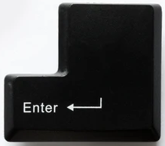
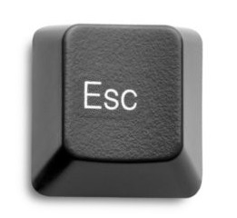


Good Luck

